I have a dilemma, so I need you guys to fill out a quick survey for me. On one hand I want to take advantage of the Custom Objects feature with my apps. On the other hand, using that feature restricts the app to Vault Professional only.
For example, the 2013 version of Project Thunderdome could do some really cool things with custom objects, but any Workgroup/Collab users would be unable to use it.
Please take my 2 question survey to let me know what I should focus on.
The survey response was overwhelmingly in favor of custom objects, so I will make use of that feature where it makes sense to. I’ll try not to go overboard... no promises.
Here are the results:
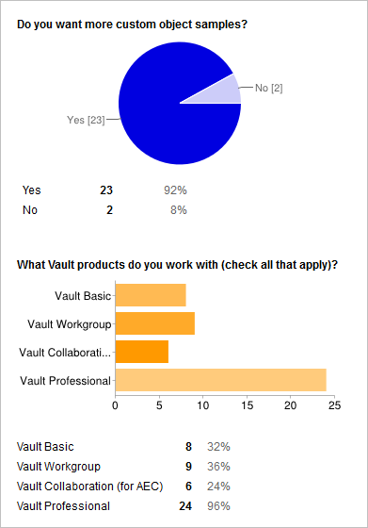
BTW, Google Docs is a great free way to create simple surveys. Special thanks to Phil Johncock’s blog article on how to set these up.

